TIME MANAGEMENT MODULE ACTION TASK BAR
NAVIGATION: MY CLIENT GROUPS>TIME MANAGEMENT>TEAM TIME CARDS
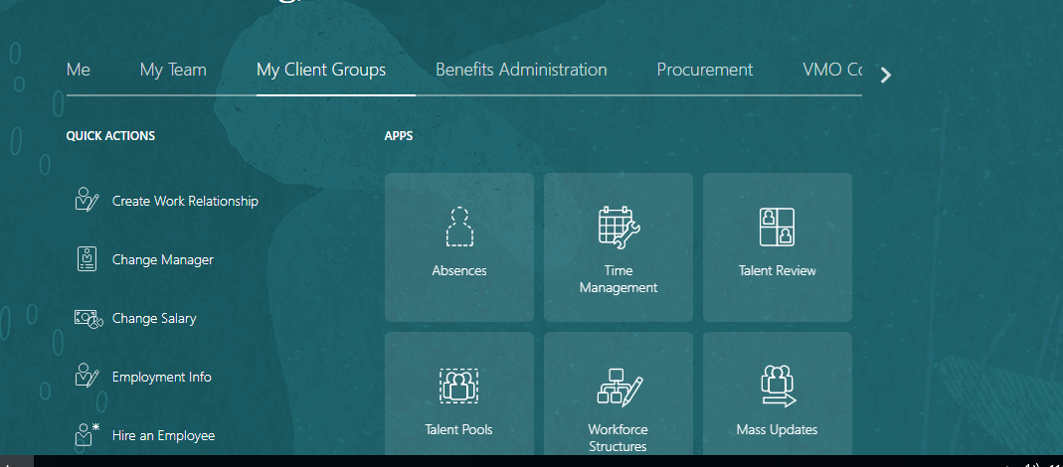

The Action Item highlighted in Yellow (Add/Edit/Delete) how can these items be removed?
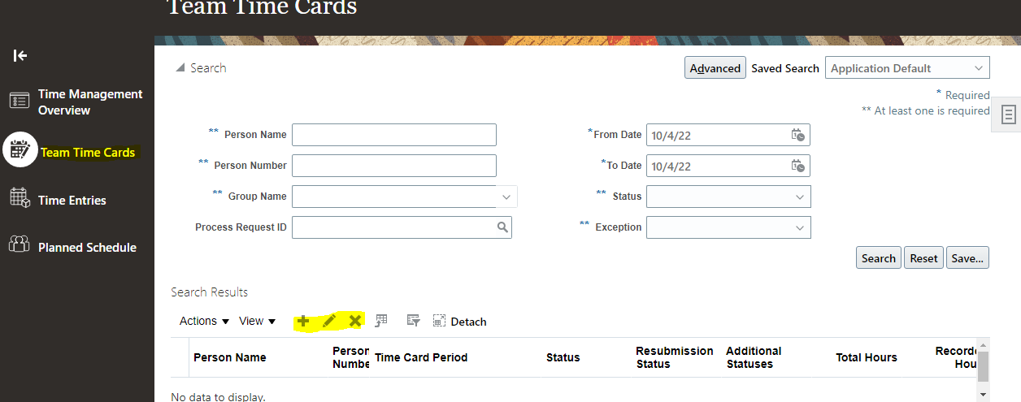
On the Action Task Button How to remove the following tasks? Create/Edit/Delete/Generate/Submit/Edit and Approve/Approve
