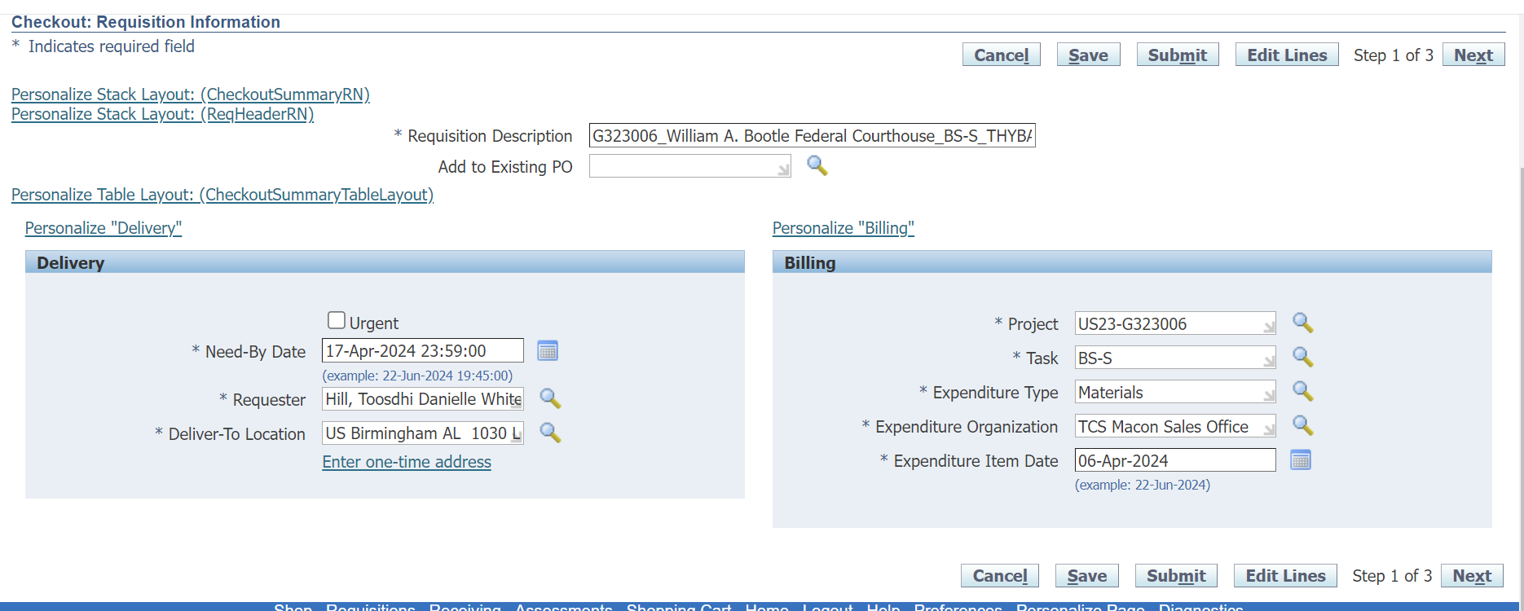
When user trying to delete the default value of Expenditure Organization from the field ,it throws Null Pointer exception.
How to resolve the above issue.
