Add/Edit Address(ME>>Personal info>>Contact Info>>Add/Edit Address)
We have created a branch with a condition in it.
Step:1

Step:2
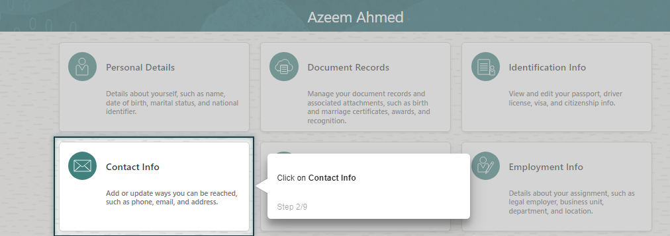
Step: 3: Added a Session Variable as Q1 = Edit, Q2 = Add
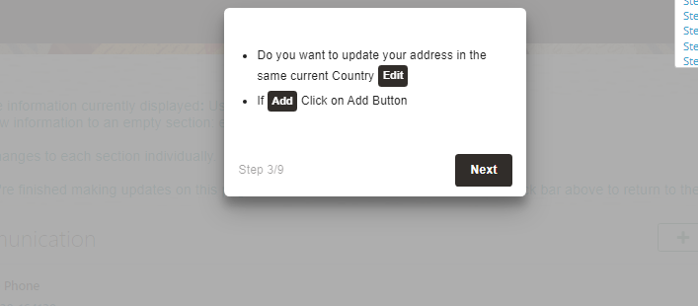
Back end: Here we added a Step branches
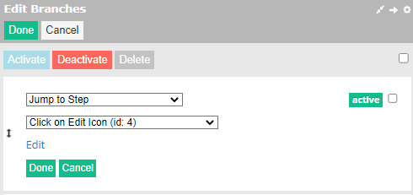
Added a condition in it
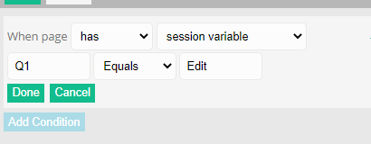
Expected Results: If User click on Edit, they have to jump to step 4.
2nd Step branch:
IF user click on Add, they must jump to Step 7.
Step 4:
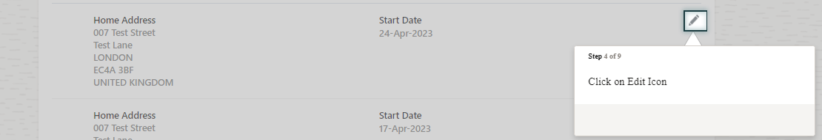
Step 5:
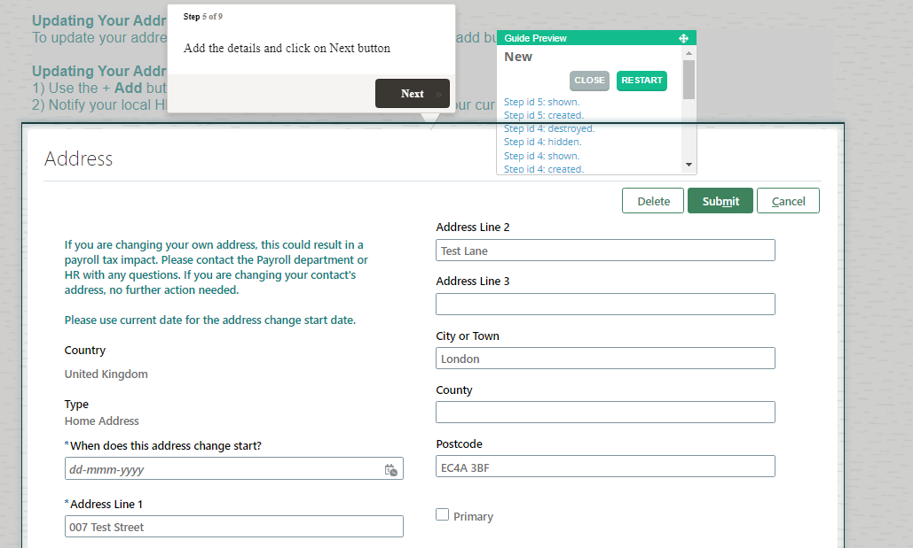

Step 6:

Step Branches: added as close this guide at this step.
Step 7:
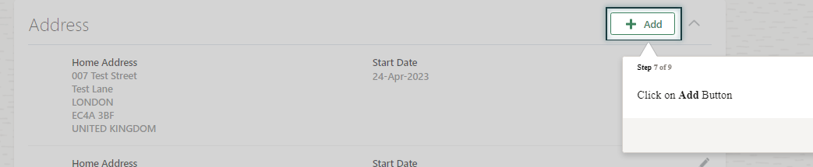
Step 8:
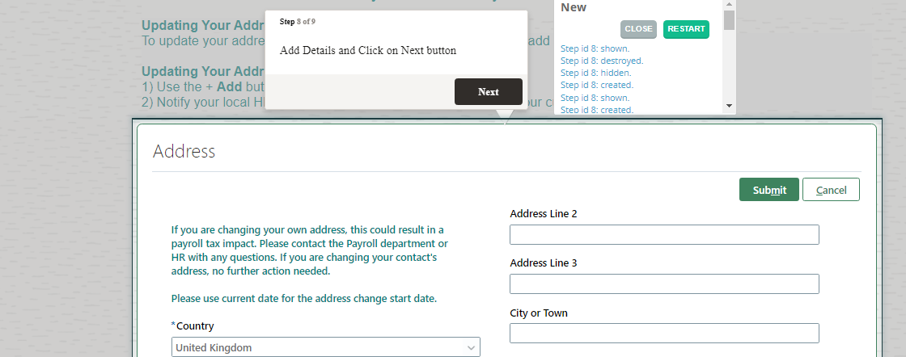
Step 9:
