Expectation from the Client

Year | Period | Begin Date | End Date
2023 | 1 | 1/29/2023 | 2/25/2023
2023 | 2 | 2/26/2023 | 4/1/2023
2023 | 3 | 4/2/2023 | 4/29/2023
2023 | 4 | 4/30/2023 | 5/27/2023
2023 | 5 | 5/28/2023 | 7/1/2023
2023 | 6 | 7/2/2023 | 7/29/2023
2023 | 7 | 7/30/2023 | 8/26/2023
2023 | 8 | 8/27/2023 | 9/30/2023
2023 | 9 | 10/1/2023 | 10/28/2023
2023 | 10 | 10/29/2023 | 11/25/2023
2023 | 11 | 11/26/2023 | 12/30/2023
2023 | 12 | 12/31/2023 | 2/3/2024

Result output in oracle with different selections

Calendar with Frequency “454” and format “Period numberYY fiscal year”.
- Period name starting with 1-24 contradicting to the Expectation 1-23
- Year is populating as 2024 contradicting to the Expectation 2023

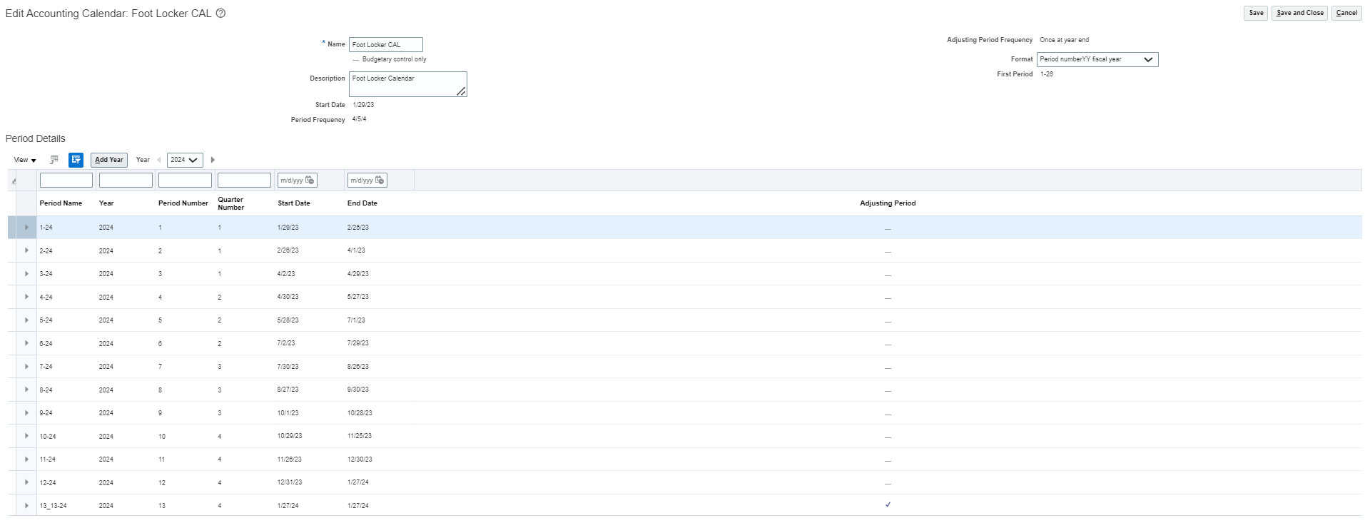

Calendar with Frequency “454” and format “Period numberYY calendar year”.
- Period name starting with 1-23 meeting the Expectation 1-23
- Year is populating as 2024 contradicting to the Expectation 2023

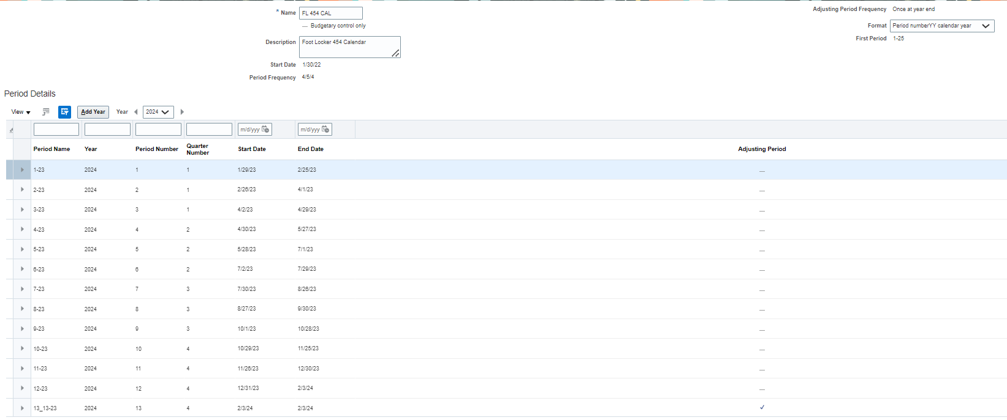

Calendar with Frequency “Other” and Number of standard Periods “12”.
- Period name starting with 1-22 meeting the Expectation 1-22
- Year is populating as 2022 meeting Expectation 2022.
- Backend tables still showing fiscal year as “2023”

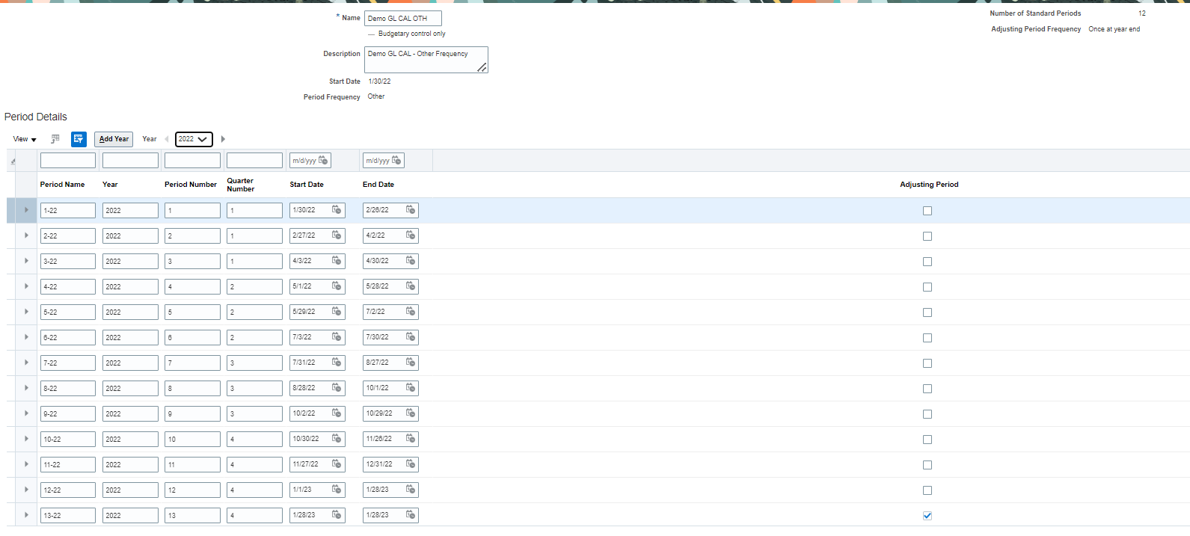

Backend data report
UI shows the Green highlighted.
Back Table shows Fiscal year (Orange Highlight) as 2023
