NACHA Rules

IAT

Currently there is not an out of the box solution within CCB, CCS, C2M that allows for our utility customers to identify International ACH Transactions (IAT) which is required in order to meet NACHA Operating Rules & Guidelines.

I have attached a copy of the Automated Clearing House (ACH) User Guide from Wells Fargo which outlines the definition of IAT truncations and how they should be handled (refer to the section for International ACH Transactions (IAT) starting on page 12 of the attached documentation).

Any violation of not meeting the IAT guidelines will result in a fine to the utility company for not adhering to the NACHA operating guidelines. Therefore, our current customer implementation made the decision to block payments that would qualify as an IAT transaction.

The only way in which someone can know which bank routing/bank account number combinations (e.g. bank account patterns) quality as IAT is to review guidelines from the utility ACH Processor, which, in our specific case is Wells Fargo.

Below are details related to IAT:
Specific rules regarding what information must be gathered from the customer and provided to the network, and how IAT transactions must be formatted when sent to our bank:

Refer to NACHA OPERATING RULES & GUIDELINES - Section 5, Chapter 43 (approximately 70 pages)

Definition of IAT:
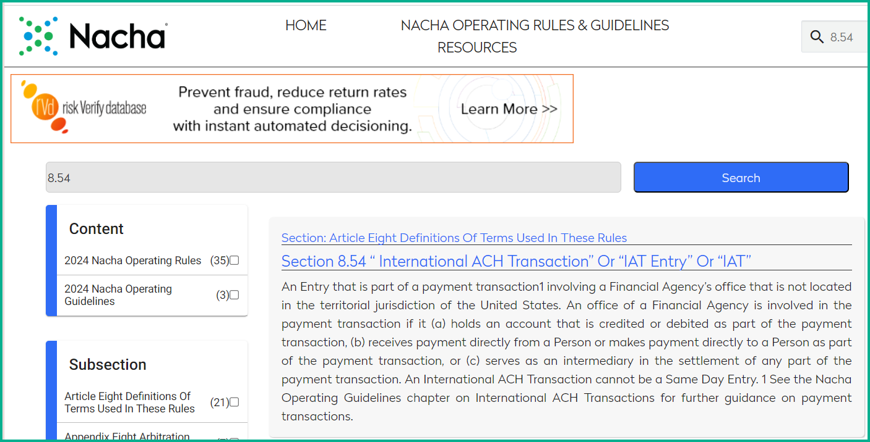

Data Requirements:
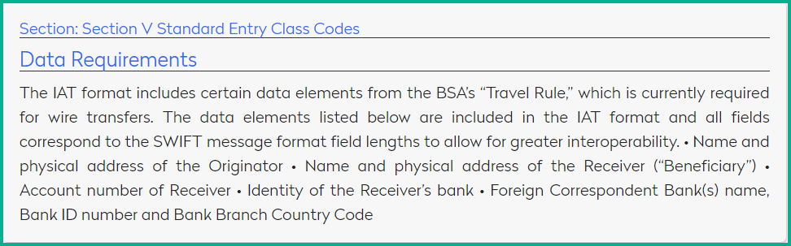

Laws and Regulations, in addition to NACHA, that all ACH Originators must comply with:
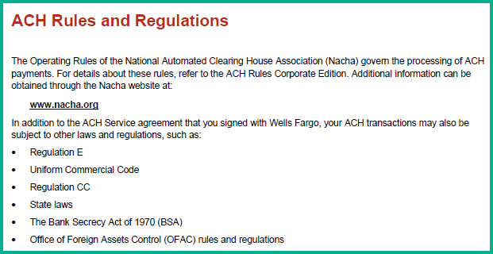

Explanation of why a transaction any ACH Originator initiates would qualify as an IAT:
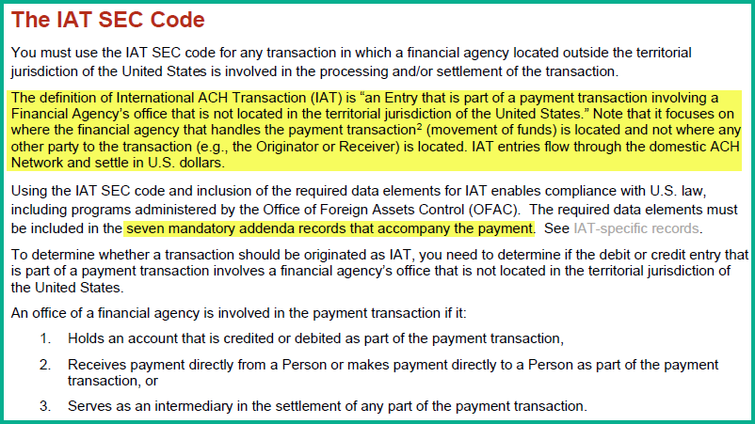

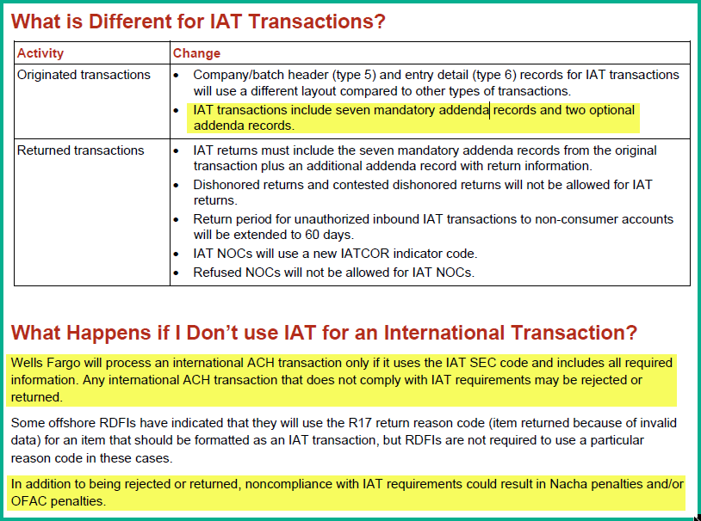

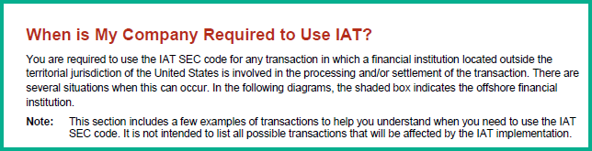

Specific Example that applies to all U.S. ACH originators:
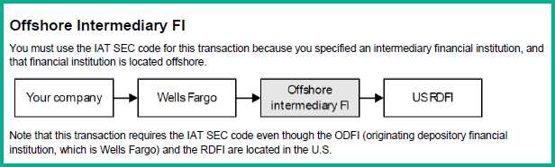

Current list of Bank Routing Number/Bank Account Number combination patterns that qualify as IAT:

Bangkok Bank
Transactions to beneficiaries at Bangkok Bank require origination using the IAT SEC code.
- Routing Transit Number 026008691
- All account numbers

Citibank
Transactions to beneficiaries at Citibank branches in the U.S. may be routed by Citibank outside of the U.S., which requires them to be submitted using the IAT SEC Code. This applies to transactions that meet all three of the following conditions:
- Routing Transit Number 031100209
- Account numbers are 17 digits long
- Account numbers beginning with 7002, 7003, 7024, 7027, 7040, 7041, 7042, 7043, 7044, 7138, 7238, 7338, and 7772

Deutsche Bank
Transactions to beneficiaries at Deutsche Bank require origination using the IAT SEC code. This applies to transactions that meet both of the following conditions:
- Routing Transit Number 021001033
- Account numbers are longer than eight digits

Note: Transactions with check conversion Standard Entry Class (SEC) Codes (ARC, BOC, POP and RCK) are excluded.
ACH Implementation Guide 26 June 2022

Royal Bank of Canada
Transactions to beneficiaries at Royal Bank of Canada branches in the U.S. may be routed by RBC outside of the U.S., thereby requiring them to be submitted using the IAT SEC code. This applies to transactions that meet both of the following conditions:
- Routing/transit number 026004093
- Account number does NOT begin with 01269

Wells Fargo
Transactions to beneficiaries at Wells Fargo in the U.S. are routed outside of the U.S., which requires them to be submitted using the IAT SEC Code. This applies to transactions that meet all three of the following conditions:
Routing Transit Number 121000248
- Account numbers are 17 digits long
- Account numbers beginning with 1775, 2606, 4148, 4248, 7184, 7284

ACH transactions that meet the above conditions must be processed as IAT.

