Error when accessing CTI

Loginto Oracle cloud
Service > Service Request
Click on Telephone icon. Agen Name shows
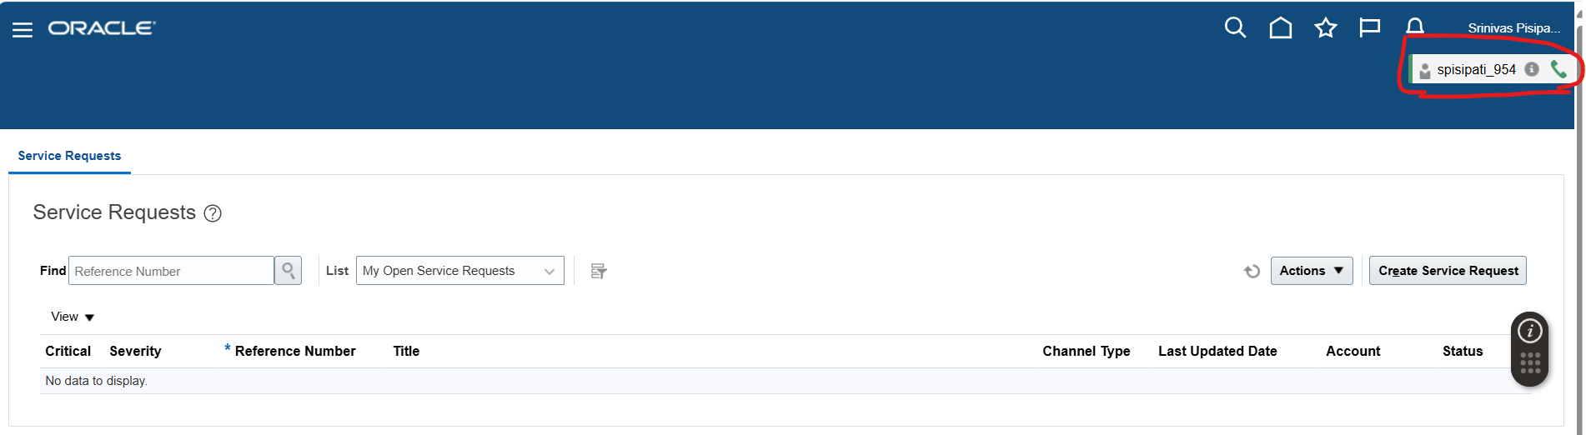

Connect to the Host address
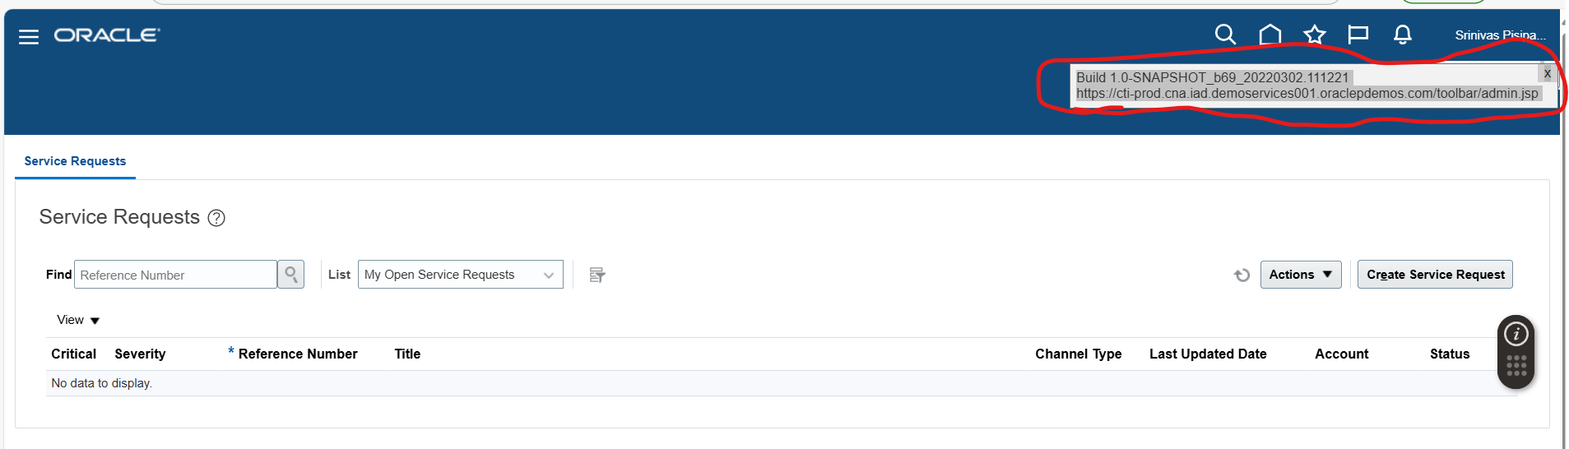

Iam assigned as agent
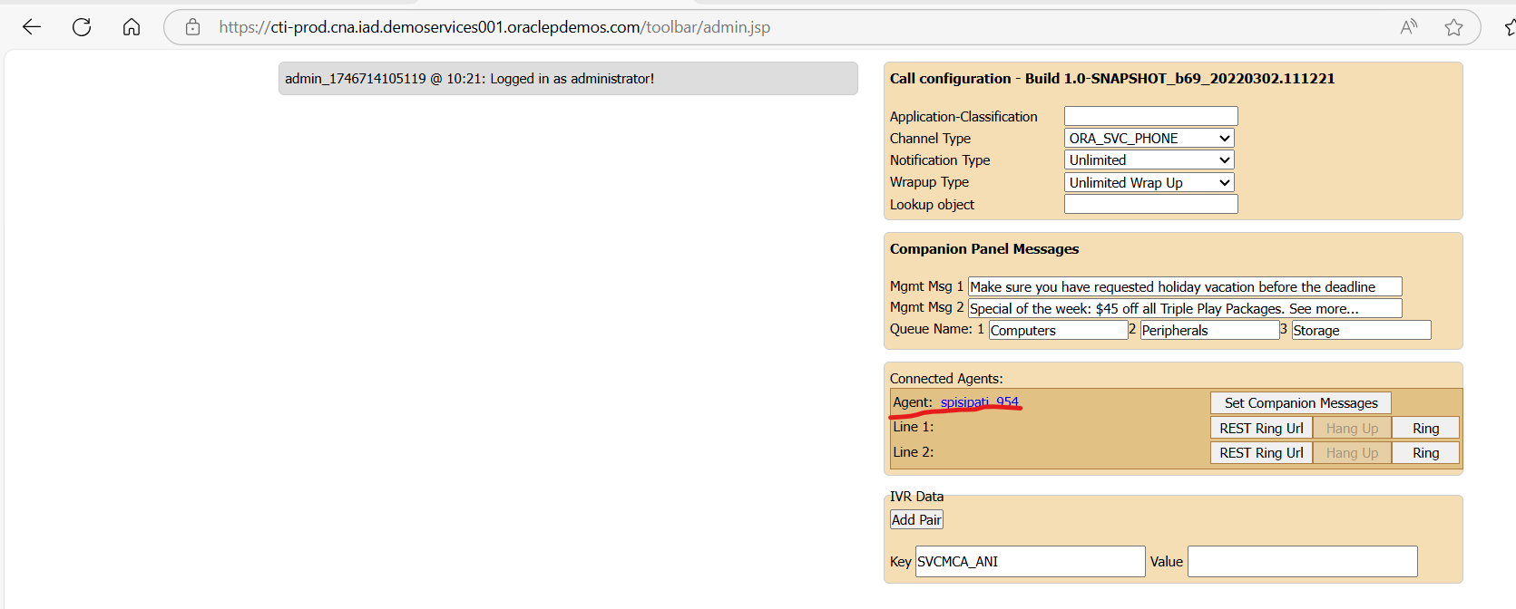

Click On ring
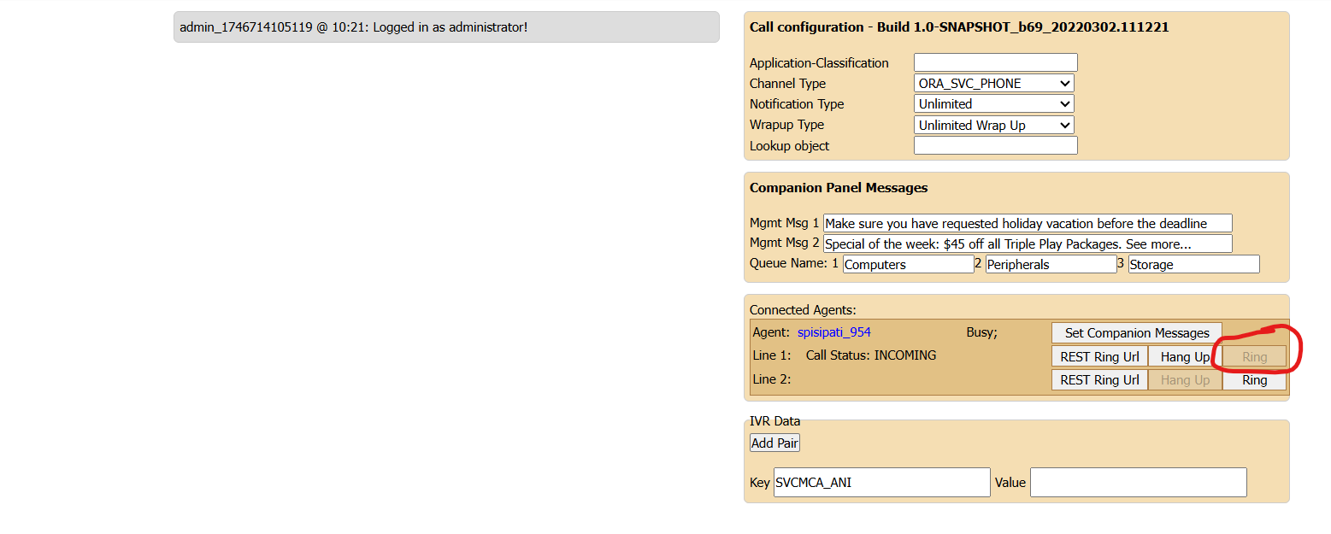

Accept the ring
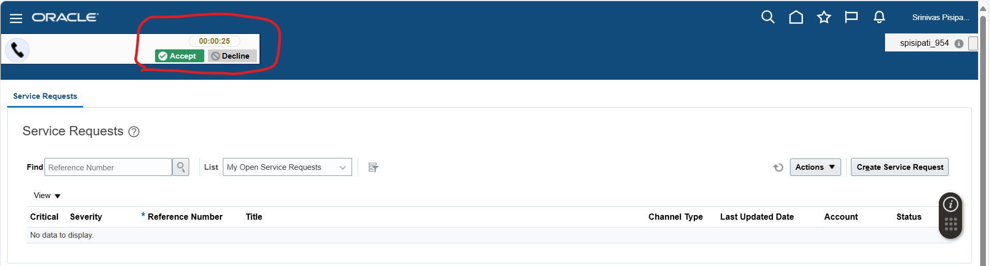

Accept the ring and contact information page popsup

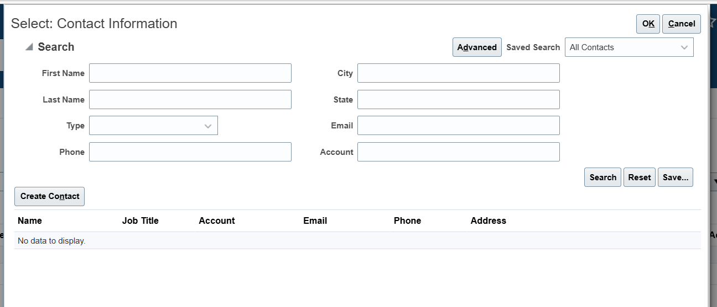

Gave a contact name and searched. Got error as below



