We are using eclipse, spring boot and RestTemplate.
The complete code is this one:
@GetMapping("/processRestGeneralWS2")
public String callGeneralRestWS2(){

try {
RestTemplate restTemplate =new RestTemplate(new HttpComponentsClientHttpRequestFactory());
HttpHeaders headers = new HttpHeaders();
JSONObject responseBody = new JSONObject();

String username = ""; //Not included for security reasons
String password = ""; //Not included for security reasons

headers.setBasicAuth(username, password);
headers.add("Content-Type", "application/json");
String uri = "https://ENVIRONMENT_CODE.fa.em2.oraclecloud.com/fscmRestApi/resources/latest/receivablesInvoices/1479087";

HttpEntity<String> request = new HttpEntity<String>(headers);
System.out.println(request.toString());
System.out.println("------------------------------------");
ResponseEntity<String>resp = restTemplate.exchange(uri, HttpMethod.GET, request, String.class);

System.out.println(resp.getStatusCode().toString());
System.out.println("------------------------------------");
System.out.println(resp.toString());
System.out.println("------------------------------------");
responseBody = new JSONObject(resp.getBody());
System.out.println(responseBody);

}catch(Exception e) {
System.out.println(e.getMessage());
System.out.println(e.toString());
}
return "Finalizado";
}

The results on the console for the println are the following:
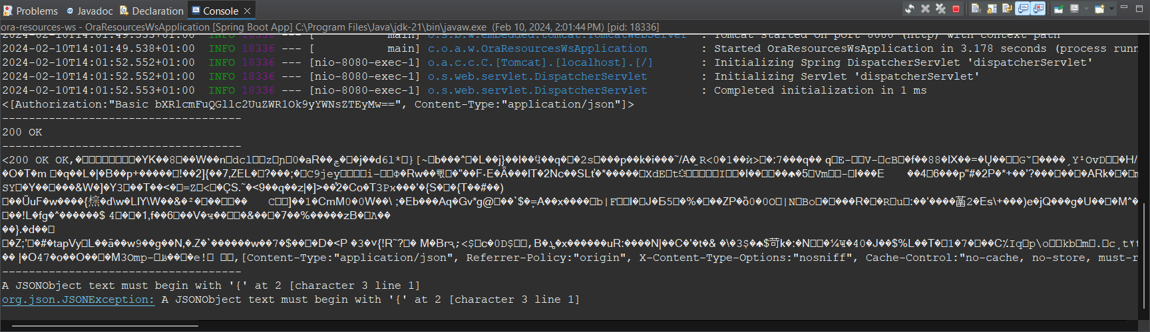

If we declare the class with the attribute we can get the values of the Jason object, but if we try to get on string format, we receive what is shown on the image. If we use SoapUi o Postmant, we get the response correctly.

